Ceremonial Lock-in Preorder
Name:_________________________________________
Phone:(___)____________________________________
Email:_________________________________________
Moccasin Kits: Please indicate size, size 7 to 12 (by whole sizes). They cost 27$ each. ______________
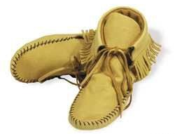

Please return the form to Scott Mayberry (scottamaberry@gmail.com) or Chris Colletti (ccollettioa@att.net)
All materials are supplied by Tandy Leather
Leather Hide: Can be used to make leggings, breech cloth, war shirts, etc. Please indicate the type and what you are planning (deer skin is 4.59$/sq ft and the cow hide is 5.99$/sq ft; prices are subject to change due to the supplier’s prices):
Genuine Deer Skin Deer-tanned Cow Hide
What are you going to make (most things take about 8 sq ft):
Leggings Breech Cloth War Shirts

