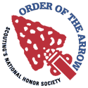
New Horizons Order of the Arrow
OA Troop Rep Information Packet

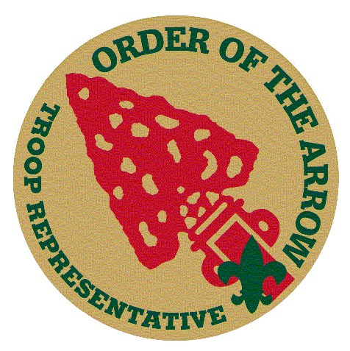

Chapter Chief
Chris Kreienkamp
cjkreienkamp@gmail.com
(314)452-1750

OA Troop Rep Chairman OA Troop Rep Advisor
Michael Kreienkamp Mr. Ray Kreienkamp
mailto:mikekreienkamp@gmail.com kkamp8@gmail.com
(314)821-8750 314-821-8750

OA Troop Rep Committee
Michael Kreienkamp William Kraatz

Updated: 11/15
“Let it be remembered that the Order of the Arrow was created to help the unit - to help it
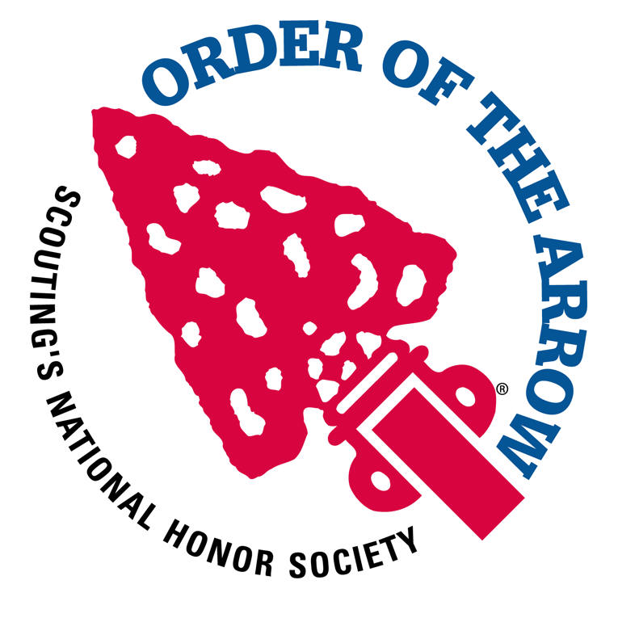
present its membership a better ideal of the inner qualities of the good Scout camper. Qualities of
character, like cheerfulness and service, are hard for a boy or a man to understand in the abstract. They come easier when seen in human life. Let us realize the significance of the Order in the unit – for the unit is our best hope in Scouting.”
Dr. E. Urner Goodman
Founder, Order of the Arrow

What is the Order of the Arrow Troop Representative?
The Order of the Arrow Troop Representative is the youth liaison between the local OA Lodge and his Chapter and his unit. In the unit, he will serve as a communication and programmatic link to and from Arrowmen, adult leaders, and Scouts who are not presently members of the Order. He will do this in a fashion that strengthens the mission of the Lodge, the purpose of the Order, and the mission of the Boy Scouts of America. By setting a good example, he will enhance the image of the Order as a service arm to his unit.

So What Does This Mean?
The Order of the Arrow Troop Rep is a cool position in the Troop. It is a leadership position. The OA Troop Rep has a large set of responsibilities in his Troop. It is not just a stepping stone from Scribe to PL or something along those lines. It is an important and fun position in itself that needs a strong and determined leader. The OA Troop Rep position can count toward the leadership requirements in Star, Life, and Eagle. The OA Troop Rep has an important role as a communicator and leader. The next two pages will explain the important link.

What are the requirements for becoming an OA Troop Rep?
All you need to be to become the OA Troop Rep is to be a registered and active member in your Troop and at least an Ordeal member in the Order of the Arrow. You should stay in the OA Troop Rep position for at least six months, although we hope you will stay in this position for a longer time.

What If I Just Became the OA Troop Rep? What Should I Do?
We now have a list of all of the OA Troop Reps in our District. We will be using this list to communicate directly with all of the OA Troop Reps. If you become your Troop’s OA Troop Rep, it is important that you send the OA Troop Rep Chairman your contact information so that we can send info to you. The OA Troop Rep Chairman will also talk to you about your duties and how to learn more about your role.

What if our Troop does not have many very active OA members? What if no one needs the leadership position?
Although many people may look at this position as just a leadership role, we hope that everyone will come to see the importance of this position beyond just the leadership role that allows a Scout to advance in rank. This is an extremely important position, as will be demonstrated on the next page. It entails many vital roles. Consequently, even if no Scout in the Troop needs the position for advancement, we ask that you have a Troop Rep anyway, possibly either the SPL or another Older Scout to lead the program. Each Troop needs a leader of the OA program, so we in the NHOA Chapter need you to designate a leader of the program in your Troop (even if you do not need one for advancement purposes). Similarly, if your Troop only has a few OA members, then the OA Troop Rep is even more crucial. As you will see in the next section, the OA Troop Rep has many duties other than just with OA members, and the key to increasing OA membership in your Troop may lie just in appointing an OA Troop Rep.

Where can I find more information on the OA Troop Rep Program?
The Officers and Chairmen of our Chapter and Lodge can answer most of your questions on the subject by emailing them or just speaking with them at Scouting events. If you would like some websites to look at, please check out the following sites:
- New Horizons OA website: www.newhorizonsoa.org under the OA Troop Rep Blog
- National Order of the Arrow Website: http://www.main.oa-bsa.org/programs/ttr/
- Shawnee Lodge Website: http://www.shawneeLodge.org/downloads/Troop_OA_Rep.pdf

Communication Diagram
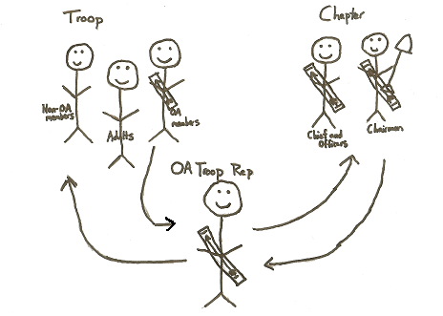

Two Way Communication Through the OA Troop Rep
OA Chapter to the Troop
Troop to the OA Chapter

OA Chapter to the Troop
The OA Chapter relies on a leader from the Troop to carry all of the information back to the Troop. Although the Chapter sends out fliers and does promotion in many different places, the OA Troop Rep is the best way to communicate from the Chapter to the Troop. The Troop for the most part has three different divisions: OA members, Non-OA members, and Adults. The OA Troop Rep has an important role with each.
OA Troop Rep with Non-OA members:
Although it would seem that the OA Troop Rep could do little for the Non-OA members, the OA Troop Rep has an important role with these Scouts. Most of these Scouts are younger or do not have the requirements to be eligible for the Order of the Arrow. Thus, with these Scouts, the OA Troop Rep should:
- Talk about the Order of the Arrow periodically throughout the year with these Scouts and get the Scouts excited about the OA. Let these Scouts know the cool current happenings in the OA.
- Encourage year round camping in the Troop
- Encourage Scouts to actively participate in service projects
- Show Scout Spirit by adhering to the Scout Oath, Scout Law, and OA Obligation
- Enthusiastically wear the Scout uniform correctly
OA Troop Rep with Adults:
Although Adults could be divided into different categories, and some would be OA members and some would be non-OA members, the OA Troop Rep should work with adults to teach them about the OA. They should also let them know about upcoming events and invite them to attend. The OA Troop Rep should also have an OA Troop Advisor in each Troop. The OA Troop Advisor lends a hand to the OA Troop Rep in things such as Ceremonial Teams and other more difficult tasks.
OA Troop Rep with OA members:
This is the most important part of the OA Troop Rep’s responsibilities. What we suggest is that at most Troop meetings, maybe at one every month, the OA Troop Rep has a short meeting with all of the Arrowmen aside from everyone else. The purpose of this meeting is to discuss all of the cool things that are open to these Brothers by virtue of being Arrowmen. These monthly meetings should speak of all of the things currently happening with Order of the Arrow. Here are some of the things that need to be discussed or thought about at the meeting:
- Enthusiasm for the OA. The OA Troop Rep needs to keep enthusiasm high among the Arrowmen for participating in OA events.
- Advancement towards Brotherhood and Beyond Brotherhood. Most people don’t know how to proceed with getting to these next ranks. The ideal goal for the OA Troop Rep should be to get all OA members to Brotherhood. At these meetings, you should speak with all of the Arrowmen about what still needs to be completed to get to Brotherhood or Beyond Brotherhood.
- Talk about upcoming events. Try to get lists of Scouts who will be attending upcoming service projects, meetings, and other events. Distribute flyers and other info.
- The OA Troop Rep should try to get his Arrowmen interested in Ceremonial Teams. Ceremonial Teams are a huge part of the OA, and the OA Troop Rep should do his best to put together a Troop team or try to get at least a few Scouts from his Troop interested in the program.
- Organize Programs such as Camp Promotion and Elangomats.
- Ask if anyone has any suggestions that they would like to see made at the Chapter or Lodge level to make the OA program more fun and more interesting.

Troop to OA Chapter
An extremely important part of the role of the OA Troop Representative is communication from the Troop to the Chapter. Most people have never thought about this aspect of the communication before. The Chapter needs feedback from the Troops about the OA events. For example, we want to know what we could do better, what could be more fun, what things you would like changed. It is only with this communication that we can make improvements in the Chapter and make events more fun. We also would like to hear back from your Troop about things such as Camp Promotion and Ceremonial Team progress. For some events, like certain Service Projects, we need notification from you of who is attending events. You might ask, “Well, we have ideas, and we want the Chapter to hear them, but how can I get this info back to the Chapter?” Here are the ways:
- We will be having OA Troop Rep meetings, hopefully twice a year, led by the OA Troop Rep Chairman, to talk with the OA Troop Reps about their position and what suggestions they have for the Chapter from their Troops. At these meetings, we will also have training for the OA Troop Reps. To make sure that the OA Troop Rep’s message is communicated to the Chapter, all of the officers will attend the meetings, and many Chairmen will also be at the meetings to make sure that the suggestions are heard and are given serious consideration.
- Since every Troop Rep has an OA Troop Rep Committee Member that will be talking with them at least monthly, they can definitely express their ideas to the OA Troop Rep Committee member, and then the OA Troop Rep Committee member will communicate all of their findings back to the Chapter Officers and Chairmen.
- You can go ahead and email Michael Kreienkamp, OA Troop Rep Chairman, directly at mikekreienkamp@gmail.com. He will definitely report all of his findings to the Chapter leadership.

